***ELECTRONIC VILLAGE REGISTER***

**Low Cost Solution**

Version Number: 1.0

Version Date: DD/MM/2018

**VERSION HISTORY**

|  |  |  |  |  |  |
| --- | --- | --- | --- | --- | --- |
| **Version Number** | **Implemented**  **By** | **Revision**  **Date** | **Approved**  **By** | **Approval**  **Date** | **Description of Change** |
| 1.0 |  |  |  |  | First draft |
|  |  |  |  |  |  |

**INTRODUCTION**

The EVR project is one of the unique projects in the health sector in Malawi. It has been set up to digitize registration of birth and deaths in the villages. Despite the importance of this project, EVR system has faced a number of challenges. The major one is that it requires high investments. Upon looking at the importance of the project,there is need to device a cost effective and reliable way of sustaining this project. Therefore, this proposal aims at proposing the most effective way in which this system can easily be deployed and sustained throughout Malawi .

**PROJECT BACKGROUND**

EVR is an abbreviation for a solar powered Electronic village register project at Baobab Health Trust whose main objective is to scale up electronic village registers for measuring vital statistics in rural villages in Malawi. The project started in 2013.It has been deployed in 83 villages in traditional authority Mtema,Lilongwe. This is an area without electricity and the system sorely depends on solar power. The system has also been deployed in 4 health centers around this area.

The EVR system consists of the following things;Batteries,Solar panels, Mini tower,Desk, Touchscreen,Printer,Scanner,Radios,antennas,Dc-Dc modules,Low Voltage Disconnect,Charge controller,switch,server,Analog Telephone Adapter,Reset switch,front rear switch and PoE injector.

**PROBLEMS ANALYSIS**

As stated above, the current system poses a number of challenges, some of the challenges are as stated below;

1. High Investments

* The system consists of power and connectivity equipment which is installed at every transmission point(GVH premises).These equipments(Desk and mini tower) leads to high installation costs.Since installation of the mini tower needs manual labour. Therefore the more the mini towers the higher the cost

* It also requires intensive user training. This does not take place once since the people the project is dealing with are not conversant with the touch screens.Therefore,to ensure that the people are able to use the system effectively,more trainings are conducted hence increasing the costs.

2.Maintenance costs

* Traveling costs

The system needs more support. Due to its high downtime, Baobab staff are supposed to conduct frequent site visits to rectify all the issues connected to the site’s downtime and make the system usable again.In addition to this, the team is supposed to conduct routine supervision. These are conducted to make sure that all the users that were unable to capture data into the system are assisted accordingly.

* Hardware costs.

Most of the hardware used do not perform as expected. That is,they report to have a short lifespan(LVDs DC-DC modules and batteries).Therefore, there is need for more replacement hardware to keep the sites up always .

3.Time

* International procurement also poses challenges to the projects timeline. Hardware purchases take longer to be shipped for installation

**INTERVENTIONS**

There has been different interventions to improve the performance of sites from the time this system was deployed. Some of them includes;

1.Power

* installation of front rear switch
* Introduction of the Low voltage disconnect
* Replacement of charge controllers models(BSV to Steca)
* Change in charge by changing solar panels from 50W to 85W and from one battery to two batteries

2. Network

* Introduction of key transmission points for the mesh network
* Replacement of 5GHz mesh with 2.4GHz mesh
* Replacing Mikrotik base box 5 with Mikrotik metals in some of the sites

3.Touch-screens

* Replacement of the tablets(Nexus 7) with the j2-225 and EBN Touch-screens
* Replacement of the Touch-screen with Tablets and Raspberry pie

4.Support

* Introduction of back to office reports
* Introduction of sites checklist

5.Costs

* Employment of a Community Development Assistant
* Increased battery lifespan (Battery maintenance)
* Replacement of the ATAs with network Jumpers
* Remote site monitoring

**RESULTS**

Despite all these interventions,the system has been inefficient , being with connectivity less than 80%.Meaning ,both system users and the EVR team can face challenges if the system is be deployed throughout the whole country. The system can not be easily sustained hence making it impossible to be deployed throughout Malawi hence the development of the low cost solution.

**SUGGESTED LOW COST SOLUTION**

1. POWER

The power must be adequate to drive the hardware

* solar phone chargers
* Battery bank

2. NETWORK/CONNECTIVITY

* We will use another service provider to address networking problems. Thus;TNM/Airtel/Africas Talking
* Repeaters will be used to provide coverage in areas having connectivity problems

3. WORKSTATION

* Cell Phone
* Label Printer
* Desk

4. SOFTWARE

* USSD
  + Unstructured Supplementary Service Data is a GSM (Global System for Mobile) communication technology used to send text between a mobile phone and an application program in the network.
  + The App will be tweaked for USSD to lower the responses when searching for the service one intends to use the session for.
  + The server will be sending a text to the printer as a response from USSD request.
* Printer

The printer will not be used at each and every site.This will be done by using pre-printed barcodes. This means,Baobab staff will Pre-print the bar codes then just write on them. Then ,the ID from pre-printed barcodes will be entered when the person visit the health centers to start session and produce another barcode

SUPPORT

* Install proper monitoring tools for easy support
* The system will require minimal support
* Value proposition will also be considered as a priority to the system
* The villagers will be the ones offering the first line support for the system

**ANALYSI*S***

ADVANTAGES OF USING A MOBILE PHONE/THE PROPOSED SYSTEM

1. The most digital communication device people are using are mobile devices. It is a computer in an ordinary man's hands
2. It is cheap
3. It is easy to use and people are more conversant with it.
4. Unlike the in house system,the chief can also delegate responsibility to other people when he is engaged or away from his house
5. There will not be more labour involved in installation of the system
6. The system will require minimal support and maintenance
7. The system will require less user trainings as people are already familiar with using USSD since they already use it on their phones to buy airtime.

SECURITY

1. Enhance community ownership through civic educating the community on what Baobab is doing(project),he importance of this development to the society and encourage the people to take a role in partnering with chiefs or clerks in utilizing the facilities installed in their areas
2. Promoting community ownership of the phones by using a philosophy that has to be appealing to the villagers e.g using the MOTTO’’umoyo m’manja mwanu”where the message communicated will be the value of the phones to the people's lives.
3. establishment of EVR village committee to act as guards for the project facilities. The team will consist of the chief and other influential community members. The committee will be meeting every week and then meeting baobab officers on monthly basis to monitor the work.
4. Use of GPS tracker for actual real time tracking of the phones
5. Customize the phones to have limited access(phone encryption)

**ADDED SERVICES**

1. Verbal autopsy
2. Offline feature

**VALUE PROPOSITION**

1. Connectivity(Use of repeaters)
2. News
3. Awards

**BUDGET**

CURRENT BUDGET/SITE

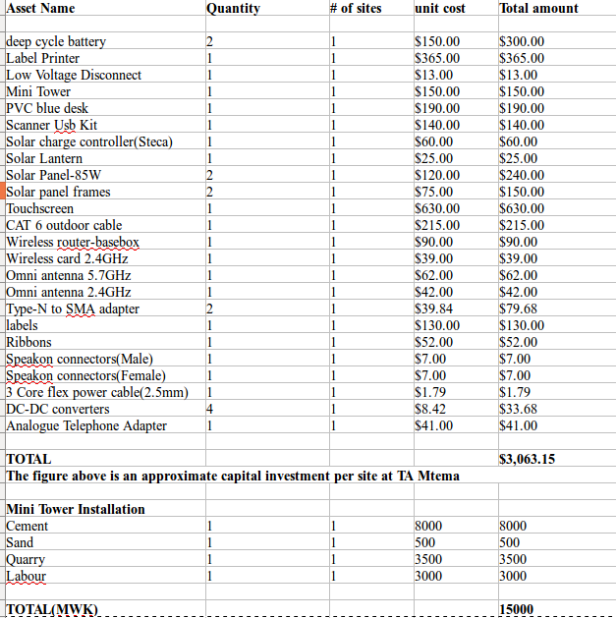

PROPOSED BUDGET/SITE

